God bless…. Greetings…… ☺

So as Ed says…. When we combine fundamentals and technicals it makes us a mature trader…

So first we go to forexfactory.com to check for announcements….

Today we find out that new home sales are up which is said to create a ripple effect in other markets like home appliances, furniture etc…

Remember that we check for these (red tag means important) economic indicators to avoid any “event based volatility” or we can know the “announced” side of the trade and use it as confirmation or a warning for our interpretation of market positioning.
☺

The most significant economic indicators are said to be GDP, CPI, PPI, trade balance, and un-employment.

Price based traders say the “price is the ultimate indicator”…so we keep aware of fundamentals just in case something happens like an immediate change in interest differential between our currency pairs creates a quick flow of money to be ware of.

So we can check out interest rates here..

http://www.fxstreet.com/fundamental/interest-rates-table/

I wrote them down so I have a reference, if anything changes…I can make a note and notice if there is a gap widening that would change global investor interest in a particular currency.

O.k so for today same old stuff…and actually, the dates of the next Central Bank meetings are posted at the site, so we can mark the calendar. ☺

Think of Japan as having lower interest rates in order to have a bit undervalued currency so exports are easier purchased by the world, which put “productivity money” into the economy….so higher interest rates in a country will raise the value…because of less debt vs. GDP…

The debt to GDP ratios in EUR dollar nations is the reason for the recent EURUSD decline and now we are at the end of wave 2 correction and expecting further decline….economies grow when productivity out weighs the debt….

How about the COT reports which presents “commercial” future contract sentiment from the previous Tuesday to Tuesday week…contracts are analyzed vs. the USD.

CHF

Long 9,487 Short 30,720 (so net short CHF)

…so our correction in USDCHF makes sense as the pair rises because CHF is said by the commerce world researchers to be falling this week vs. the dollar.

EUR

COT “commercial reportables”

Long 80,283 Short 143,118 (net short)

And if we check below this it shows changes of commitments….saying that the gap is widening on the short side…(ex: 20,000 more short…and 7,000 more long)…so this tells us more and more are taking short on the EUR.

We checked the LIBOR-OIS and it’s the same..

The COT confirms our technicals of negative correlation between EURUSD and USDCHF.

O.k. so now how about some correlation thoughts about S and P (which is a good gauge of the world’s sentiment towards risk aversion or risk appetite)

http://www.ino.com/

copy/paste the picture works better from ino.com ☺

1 month
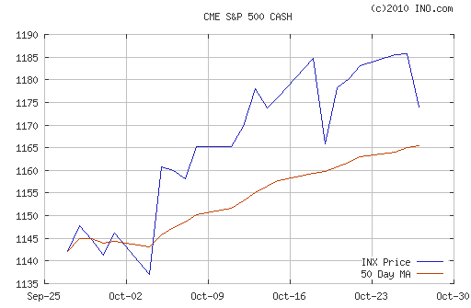

It seems a top is forming in S and P.
..and USDCHF is correcting upward… hmmm.
That makes sense….money out of S and P into USD?

Experts say that the S and P is a reflection of money volume that global investors (and U.S) feel comfortable enough to put in the equities market. The reason why we view it this way as Forex strategists is because, we use a negative correlations such as DXY (dollar index) to tell us where the flow of the money in the Interbank market (which is Forex) is going. ☺

Here is DXY.

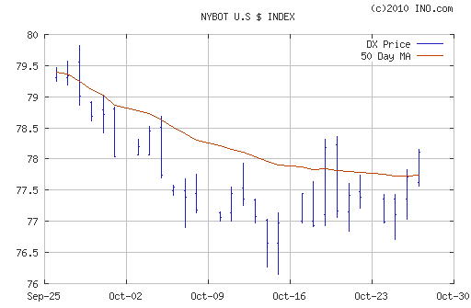

We will follow these guys… ☺
An expert said that if our correlations are not agreeing, like DXY vs Gold .. or EURUSD vs USDCHF…then something else is going on like maybe intervention from BIS, IMF or Worldbank which are institution that help fund countries and basically keep everything going when we have a global financial situation like the one recently.

Here are todays EURUSD and USDCHF….this shows that tremendous movement occurs in the corrective phase to notice, if we can work on our impulse and corrective “authentication” and “verification” technique.

EURUSD 4 hour
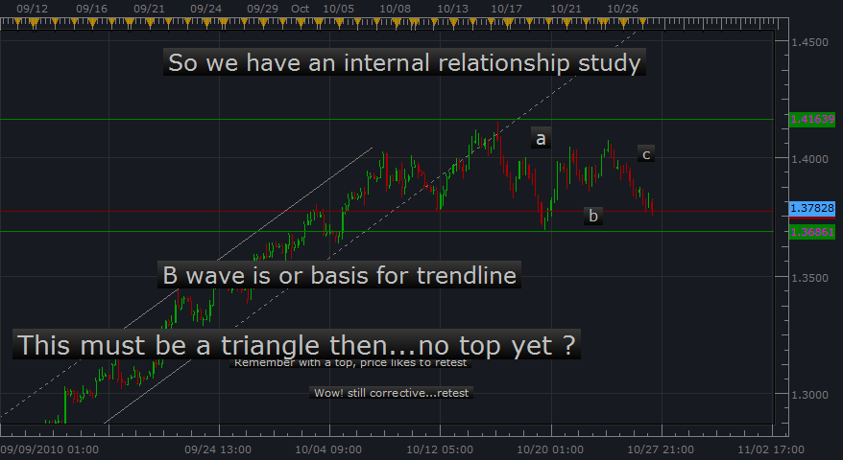
EURUSD 60 min (redraw of channeling) for c wave
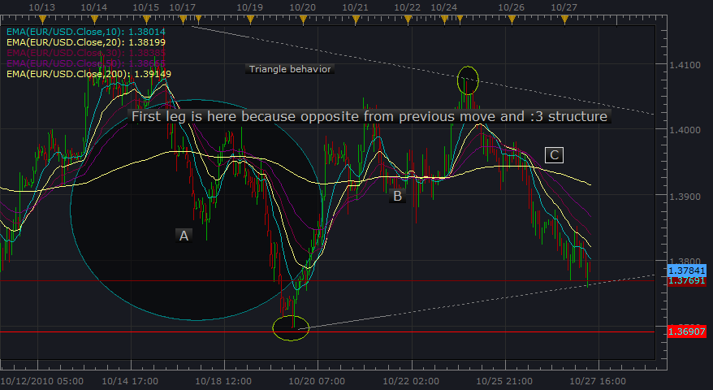

EURUSD 15 min checking out structure within ☺
When we get good at triangle authenticity, is this a setup? Remember our 4 triangle touchpoints in 60 min. give us
Confirmation of leg completion.

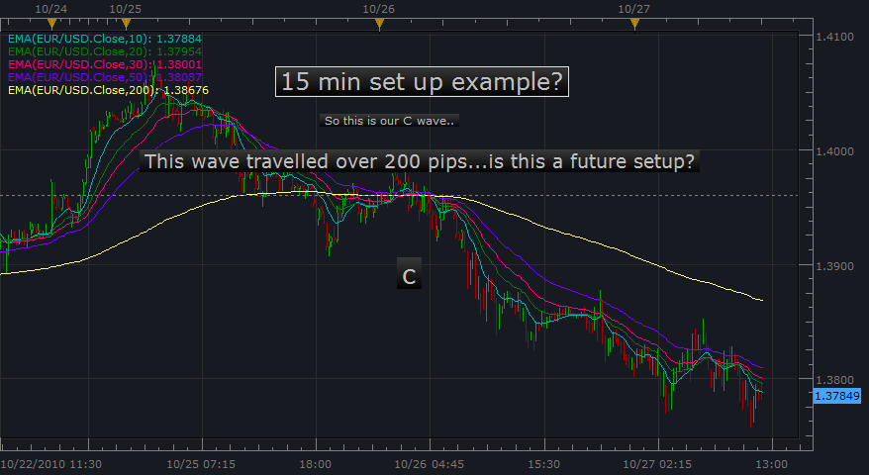

USDCHF 4 hour correcting away ☺
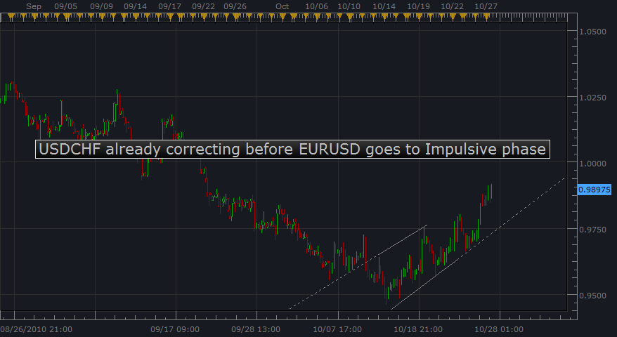

So in our negative correlations do we have “LEADERS and LAGGARDS” directing flow one before the other?.... Is this air we are breathing...?
Ha…ha…ha...hee.. ..hee…”Is this air we are breathing?” hmm… The air thing is from the Matrix movie…. ☺ By the way it’s important to breathe in hold for three seconds and exhale slowing while raising and lowering our limbs to re-oxygenate our blood and feel better. ☺

USDCHF

