The Lord is holding us up so we can pray for health and expect peace in our life…. ☺

This stuff will be about impulse verification and the rules that Elliot and Neely discovered ☺

We are going over the rules for impulsion identification and using real examples as we learn…

We know that every Elliot wave pattern “implies a transfer of power” to the next pattern.

So we want to understand the criteria of each pattern to be good detectives and find optimal market turning points…

Rules #1 :
Overlap rule, extension rule, 1/3rd rule and alternation rule…

Wave 2 cannot exceed the start of wave 1, wave 4 cannot exceed the end of wave 1, and waves 2 and 4 should alternate in price/time/complexity (subdivisions)
…( as opposed to a Terminal impulse which can over lap and has :3,:3,:3,:3,:3 etc… “corrective” structure series.)
This is a good impulsive “litmus test”

By knowing which corrective phase (wave 2 or 4) is more complex in price/time helps us know which wave extended (and at least one wave must be the longest called the extension we will find ☺ )
Our 1/3rd rule says that adjacent waves can be no less than 1/3rd in price/time of each other…which helps us in identifying which degree a wave belongs to. (a larger degree would be the 4 hour compared to the 60 min time frame)

Here is a 5th wave extension (next page), and this is confirmed because
our 5th wave extension rule says that wave 4 will be more complex in price/time…we notice here that wave 4 subdivided and can do that… ☺ (it went sideways for a bit, but we knew we were in an impulsion because of our “impulsion verification” rule we will go over more here.

EURUSD Daily

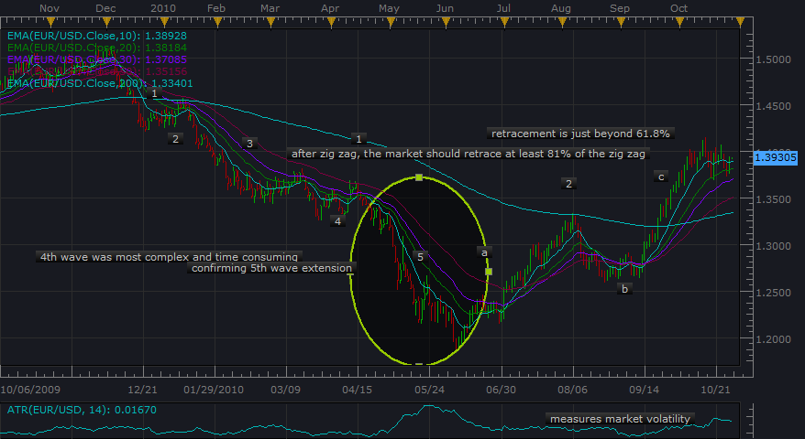

Also a quick note about the previous chart for the 5th wave extension is that wave 1 is shorter that wave 3 which is said to happen frequently when wave 5 will extend ☺

Also, one more thing…the 5th wave extension tends to go the “Golden ratio” of 161.8% based off of waves 1 and 3.

And pretty close here…interesting target ☺

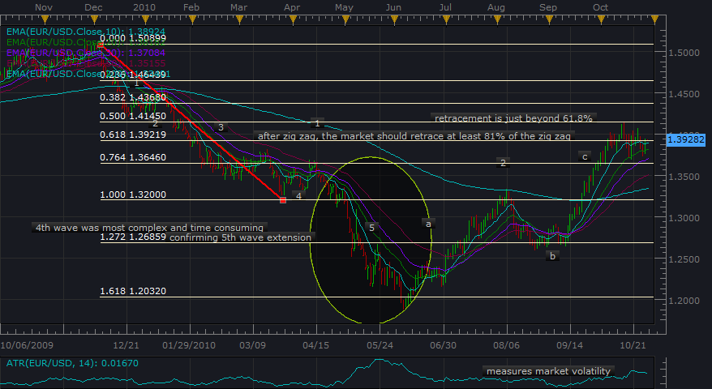

If price travels to 261.8% then we can expect a double top.

Also here is the same chart with the expected break of the waves 2-4 trendline (we will discuss this) by the 5th wave (and almost complete retracement of wave 5)…as well as the 61.8% retracement of wave 3 by wave 4 which is also part of the “Neely rules”.

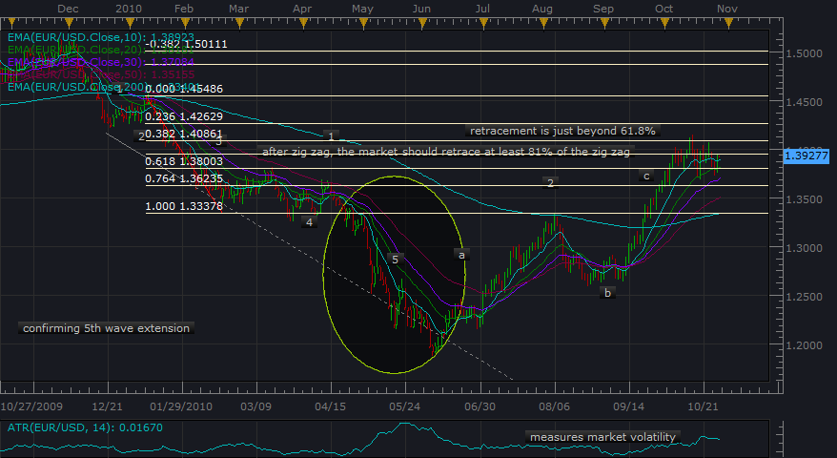

Our extended wave identification and “alteration rule” tells us about how the impulsive phase will behave… fun ☺
Also note the support/resistance at wave 4/end of wave a.

Extension rule

So as we said, one of the impulsive waves will be the longest, and can be confirmed by our other rules.
As the study goes along, we will find real examples of wave 1 extension and wave 3 extension also.

Rule of equality

Price measurements for impulsions 1,3 and 5…after we identify the extended wave, the other two waves will be near equal or related by 61.8%

So for our entry orders….we would find the highest probability turning point to the next pattern and set a trailing stop to follow along with enough space so it doesn’t get stopped out ☺ (Ed said he doesn’t even put a limit order….just lets the trailing stop do it’s thang… ☺ )
We learn about how much space to leave by the range of the retracement and our pattern criteria helps us for our “high probability” strategy. ☺

