Hey guys.. ☺ God bless……the energy known as GOD is holding us all up.. ☺
That’s why when we pray in faith or get hope, we feel better and re-energized…there really is an energy…..magic stuff ☺

EURUSD 60 min

Sooooo here is our triangle completing and we have our
4 touch points so good deal……….we should have a “state of equilibrium” and expecting a breakout at least 75% of the widest wave (price will break the high or low set by the triangle) ☺ Since we are expecting a “sellers” market, this level is our new support/resistance for our entry order to start the next impulsion. (we will study post-triangle behavior)

This one “gathers up early”, so we can call it a “Limiting triangle” (it ends 20% - 40% before the meeting of converging trendlines)

As we expect, the “apex point” is in the middle of the longest segment.

(chart is on next page)

EURUSD 60 min

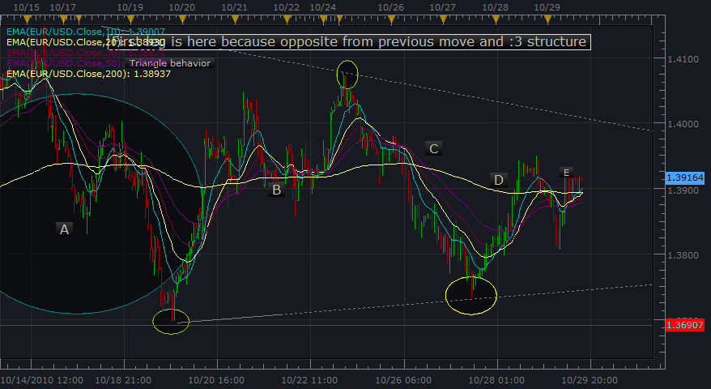

And below shows the “limiting” characteristic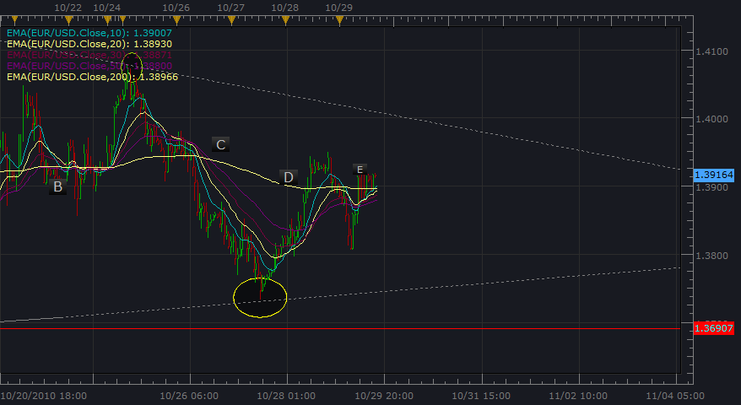

USDCHF Daily

1st wave extension

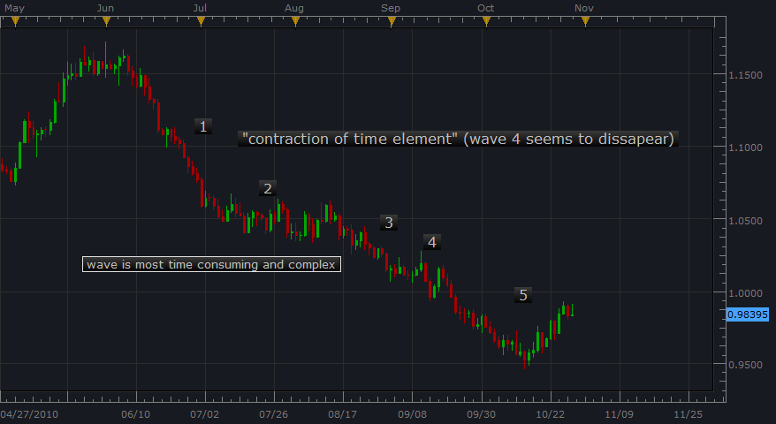

O.k. so for 1st wave extensions…

Neely, says we can expect wave 2 to be the most complex and time consuming. (4th wave may not be very visible)

The 1st wave extension may seem like a zigzag (correction) with a C wave equal to or shorter than wave A.

In the 1st wave extension, wave 5 should be the shortest… here it’s close to equal the 3rd wave though.
So for our 1st wave extension, wave 2 is a significant support resistance zone…. (time consuming and “clustery”)

For a 1st wave extension, wave 2 cannot be a running correction (or shouldn’t according to Neely that is)

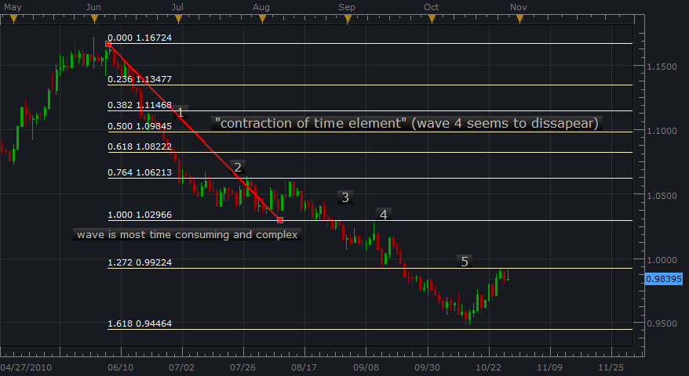

Above, as Neely says… wave 2 will not retrace more than 38.2% of a wave 1 extension.

Now lets talk about using “retracement events” to verify the impulsion. ☺

Also…. interesting how the entire impulse formation went to the “Golden ratio” as the 5th wave extension of EURUSD did ☺

Remember a structure is either Impulsive or Corrective.

For 1st wave extension, wave 5 should complete “below and away” from the upper trend line.

Neely also has a rule that wave 5 should retrace in the same amount of time that it formed, but this “retracement event” is still happening…. So the plot thickens…ha ha…hee hee… ☺

We are to expect a same degree retracement to the wave 4 area.
This would be around the top 1.02844 or bottom of wave 4 0.99237? We will find out…very cool….we are learning about wave 1 extension behavior ☺

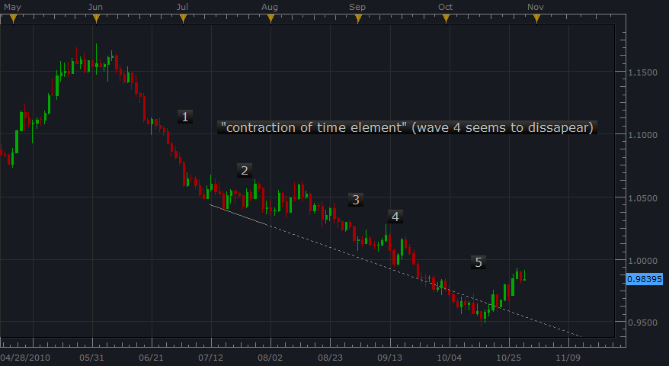

Remember that our structure :3 (corrective) or :5 (impulsive) tells us about the pattern formation…we then get a structure series that describes our formation.

Impulsion = :5-:3-:5-:3-:5

Corrections --- flat = :3-:3-:5
zigzag = :5-:3-:5
triangle :3-:3-:3-:3-:3

