We pray for quantum healing through the molecules to us, and thank you GOD for helping us have continued healing.

By the way regarding the previous study of our 4th wave being more complex and time consuming…this can happen when we are about to have a 5th wave failure (truncation), so if we are at the end of a “major” larger trend, then be careful…if anything our risk management should be strong enough that minimal stop loss happens.

When a trending impulse ends, we should not have a complete retracement unless it’s part of a larger 5th wave or c wave. ☺

So here is something interesting about countertrend/trend sentiment…. If wave 4 retraces less than less than 68.1% and most complex/time consuming, we may expect a 5th wave extension. If the larger degree wave 3 just finished and wave 4 retraces more than 61.8% we can expect a 5th wave failure. If the pattern is part of a larger degree wave a, wave 1 or wave 3 then retracement should be less than 61.8%...this Fibonacci level is important.
If retracement exceeds 61.8% after wave 1, expect a time consuming wave 2 and a c wave failure.

So loss of momentum can be expressed by 5th wave failure (should be shorter than wave 4), C wave failure, contracting limiting triangle and a terminal pattern (so check internal degree structures too when studying)

For our impulsions, we use the 0-2 trend line and the 2-4 trend line….. continuous revision implies triangular behavior.

O.k so now lets take a peak at our “fractal” representation of a larger degree 5th wave extension (Daily), our 4 hour and 60 min that seems within the larger 5th wave extension is a 3rd wave extension. ☺

EURUSD Daily

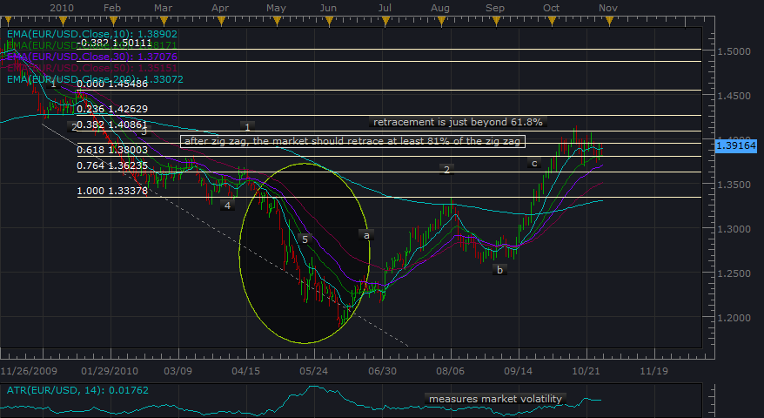

So in the above chart we notice the 5th wave extension, and in the 4 hour below we can use our
“Momentum Breakout…broken price level with impulsive sentiment” strategy to indicate the next impulsion phase may be occurring? If we were in real time… We also notice the double top formation to the left which tells us price has been gaining strength and Neely would call it a Flat correction I think?

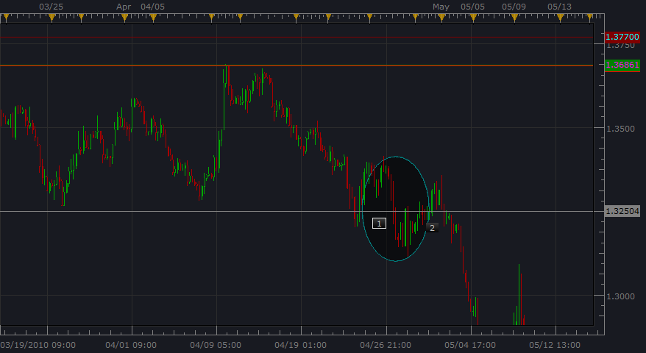

(before the breakout also notice this in 4 hour)So for this here is the lower price levels showing a declining “support becomes resistance” ☺ Seiden calls this “level upon level”

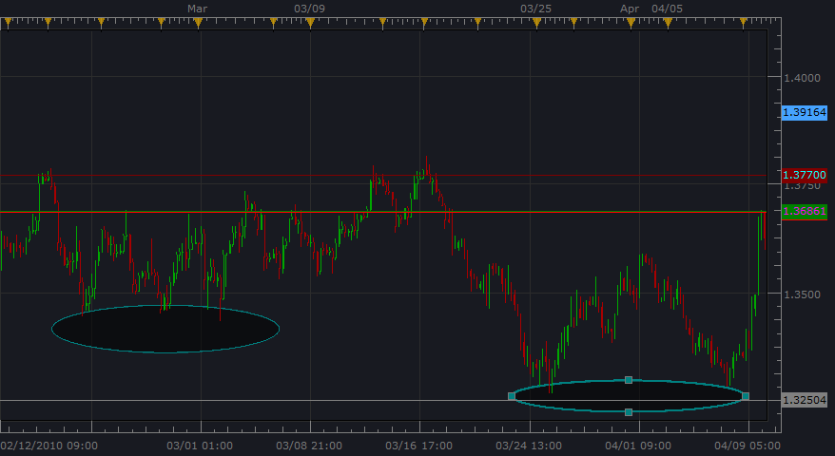

Now here is the 60 min chart, which (a Neely expert recommended 60 min because the other charts are so difficult to count waves, and also 60 min is closer to the more “significant” time frames like Daily and 4 hour) ☺

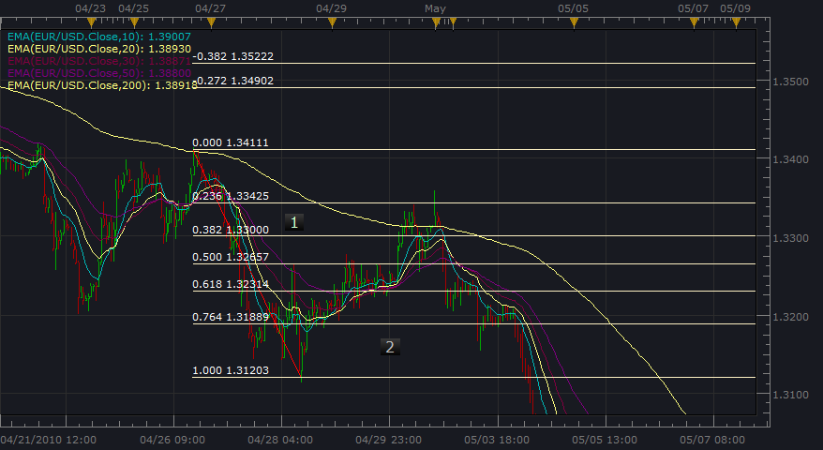

O.k. now here is just a reminder of what the end of April was like in Daily, because this is the chart that shows the sideways movement (4th wave), and is the reason we have a price level to monitor when studying 60 min.

….and here is the 60 min (remember our low of wave 4) at 1.3200. This was our level to wait for price breakage. We would put a tight stop with a trailing for wave 1, and then another entry order with a trailing… obviously the retracement is more than 61.8% (wave 2), and lots of retracement may indicate corrective behavior, but this impulsive sentiment breaking the price “level upon level” price zone may mean we will have a 3rd wave and a 5th wave extension if our wave 4 ends up contrasting and more complex/time consuming. Also notice the downward impulsive sentiment…mostly seller sentiment (red candles) in the “price event” which is valid…We know this should continue (all things equal considering our COT, fundamentals and correlations) and we are not in a larger degree “loss of momentum” pattern…

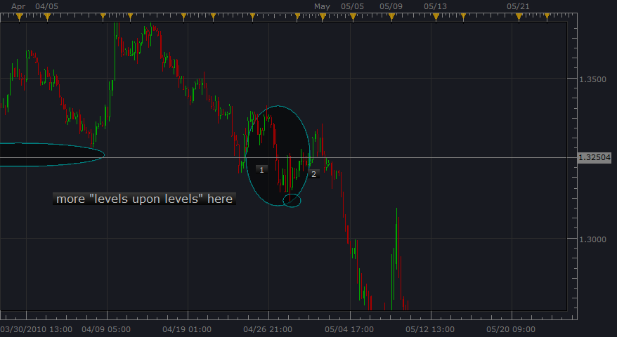

By the way, Neely says that a wave 3 extension has no reliable relationships.
So how about the wave 2 correction, we can check it’s structure to find out what we really have here…
“oh fun…the plot thickens” We are good detectives…well at least we are enjoying the journey. ☺

Remember we want to view the forest and not just the trees, which are the candles…same candle analysis is cool too…

O.k. so for this analysis, it turns out that wave 2 is more time consuming, so we can say that wave 3 extended…the sharpness in wave 4 just showing our “alternation rule” since wave 4 is steep (4 days time) and wave 2 is not….
(wave 2 took 5 days time)

Wave 2 seems to be a combination flat (strong c = trend sentiment), triangle, and flat type thing …
(learning is fun)☺ Then we have our seller sentiment again, so we place our entry order below the end of wave 1 and have a tight stop and reasonable trailing stop.

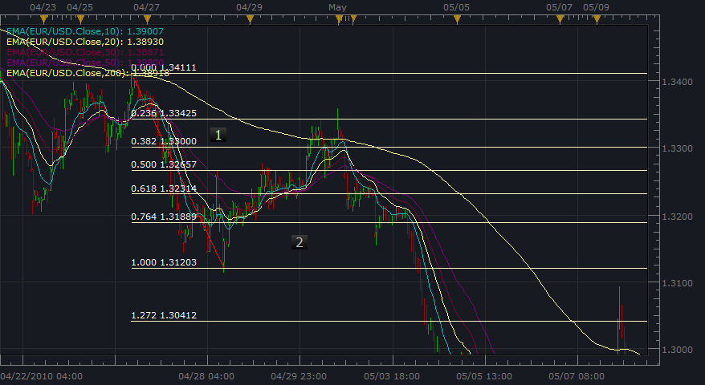

EURUSD wow! Wave 3 travels over 500 pips…then into a zigzag 4th wave…retracing near 38.2% ☺

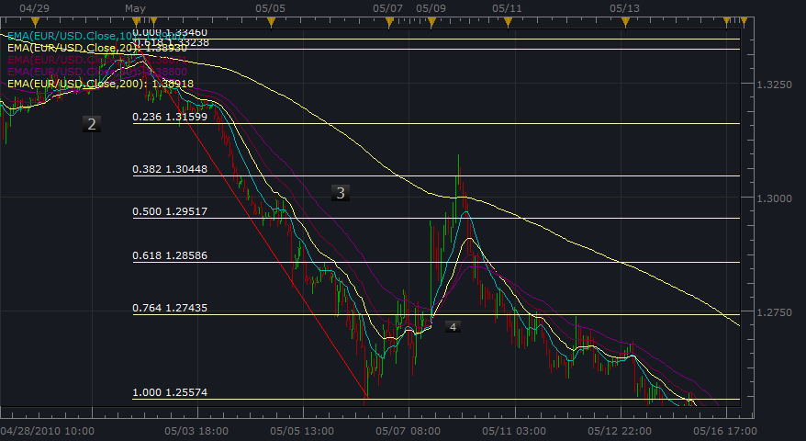

So for the next chart….when we have impulsive behavior after level upon levels sideways consolidation “building strength”, we start our impulsion thinking….

Measuring the top and end of wave 1 we can set our Fibonacci relationships and know from Neely that 100% measured move (MBO), 161.8% are key levels to be broken showing strong sentiment for continuation.

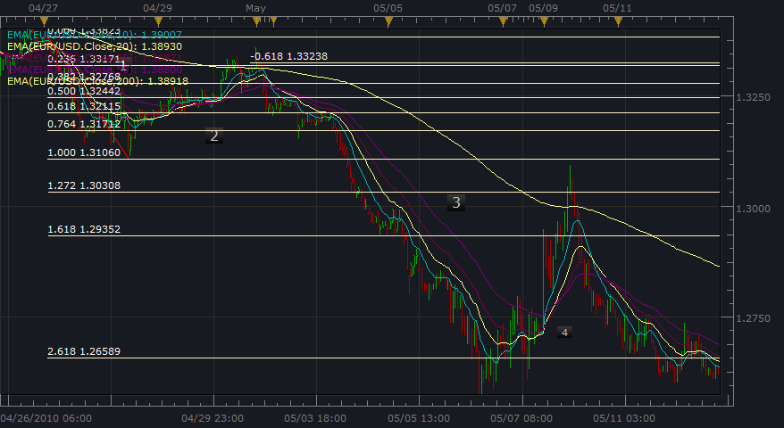

Here’s another one with the levels 100%, 161.8% and 261.8% circled (wow, this went all the way to 261.8% of wave 1)

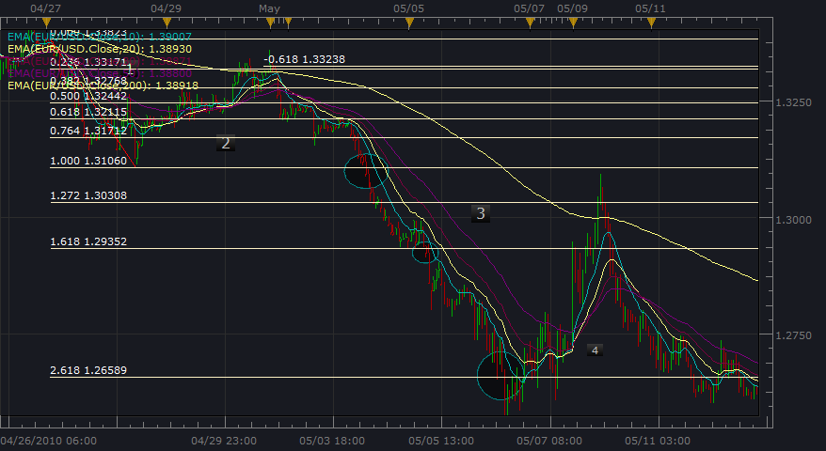
By the way check out how wave 2 and wave 4 had turning points at the same level ☺

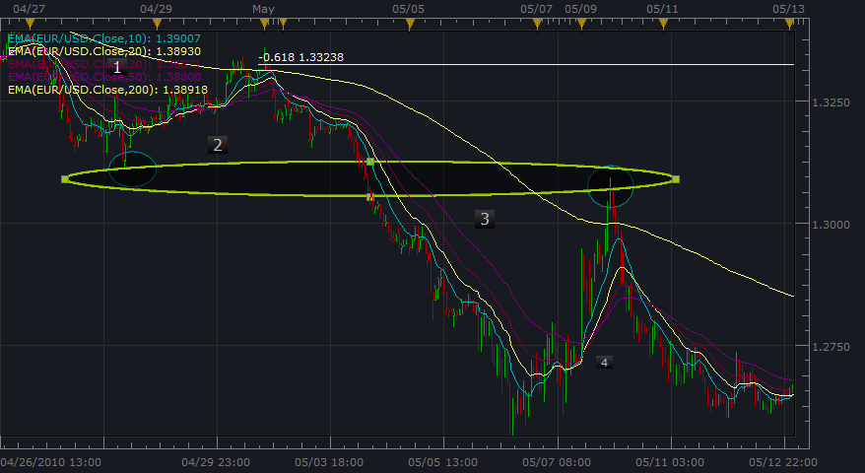

So if wave 4 begins to decline after turning at this “similar” level and we have a larger impulsion verification…can we go ahead and put the entry order before the MBO at the end of wave 3’s level? Well, our confirmations say yes, with a trailing stop of course. ☺ By the way if wave 4 retraces more than 61.8%, it finished an impulse wave of a higher degree according to Neely (so be careful of a momentum change)

Remember also that 5th wave failures are possible when wave 3 extends, even though the 5th wave is real good too.
We should check for wave 4 retracing more of wave 3 than wave 2 did of wave 1, but also, the most important thought is what the most “significant” charts are telling us. The Daily show a most complex and time consuming wave 4 so if we break the level, that larger degree 5th wave extension could be amazing ☺

Also, Neely has a “power rating” scale for corrections that help us understand the transfer of power to the next pattern…maybe for the next document study.. ☺

