We love you guys, we all are important and it’s what we got on the inside…
Here is a perspective (it’s ongoing, so no rush) of shorter time frame set ups that
Use the same “universal order” that the wave principle/Elliot wave stuff teaches… ☺

Actually, this stuff is a very special technical/Fibonacci approach from Online Trading Academy’s blessed teacher Todd Davis, and all due respect to him and the guys and gals that care enough to share this…

Anyway, here are a few chawts (a little New York accent)… “that’s it softy”… ☺

Our integrative approach is simple: ☺

- What is the larger trend of our currency pair based on the wave principle, and correlations?
- Frame the range of the most recent base object (top forming, triangle, wedge (reversal pattern), lazy m (seems like an m with lower right side), clusters. The wave principle is fractal, so it applies to all time frames. Mark key price turns and put our support/resistance lines to frame the range.
- We then use our Fibonacci guidance system to set our horizon in front of us. ☺

This is a work in progress so we will discover how the wave principle unfolds in EURUSD and USDJPY which are both at turning points and should show opposite sentiment as we go. Also we should follow USDCAD and USDCHF which have a negative correlation to EURUSD.

To start, here is our EURUSD following through with what our wave principle and correlation studies told us about USD strength and a shift in global “capital flows” (next page)

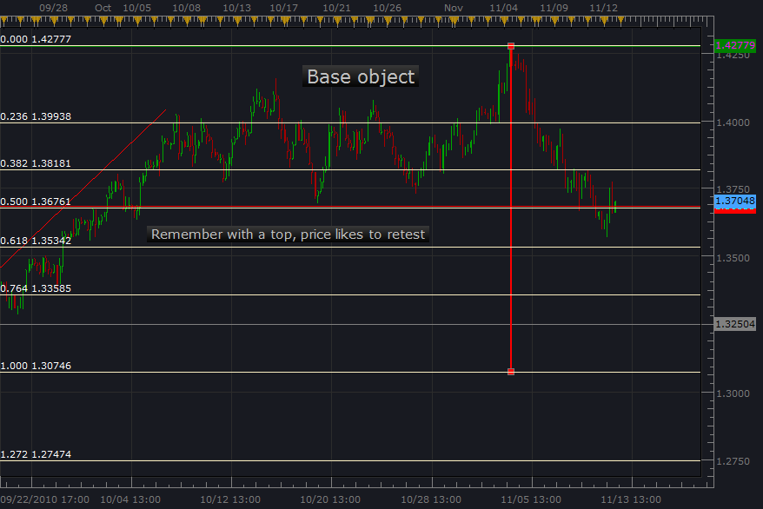

So we have our base object top formation framed with support and resistance lines, and our Fibonacci set at 0-50% from the top to bottom of the range. Our first destination will be the 100% (measured move). Now this is in 4 hour, and we use the same principle for all time frames, because universal order is fractal. This means that just as we are 38% above the belly button our other parts and veins are order using the golden ratios as well… how about that friendly ☺

So this will be our larger time frame guidance system, let check out the 60 min and 15 min to locate sentiment, find a recent base object, because there is too much risk/price movement and we will be working with 1 min. candles, so here we go ☺

Below is the 60 min, which shows the 5 waves from top of range that included the 1st wave extension, and the re-test (which is common from a base object), so we now how seller sentiment because the break away from the base object was the “sellers” taking over. ☺

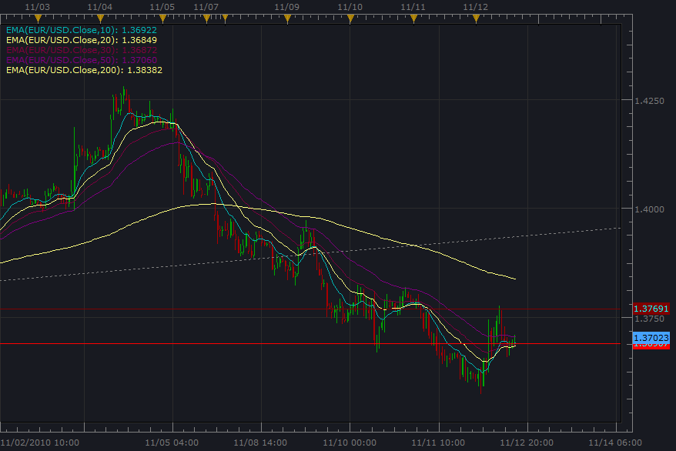

Interesting question by the way for later, when we locate the higher degree extended wave, how does the shorter 15 min, 5 min and 1 min. express this price behavior?
Well, we think this is when we move the 0-50% Fibonacci guidance system, to 0-23.6% (for base object, top to bottom of range) when price goes beyond the golden ratio “extension” fib. line. By the way, the extension part is the 100% to 161.8…. In our discovery we learn about this variable that was so kindly shared by the instructor. ☺

Lets check out the shorter time frames from the 5 wave impulsion phase and have fun.

Here is 15 min with our base object in the rectangle and the Fibonacci guidance system for this time frame. Our next ones will be even more interesting about how the impulsion phase and corrective phase evolves.

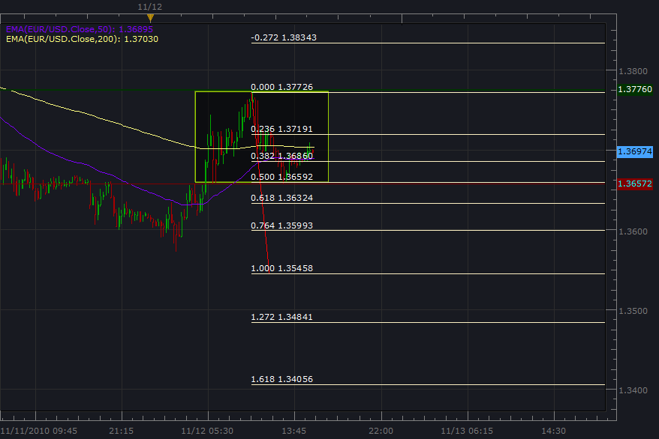

O.k so now the 5 min. “structure within the structure”

EURUSD 5 min.

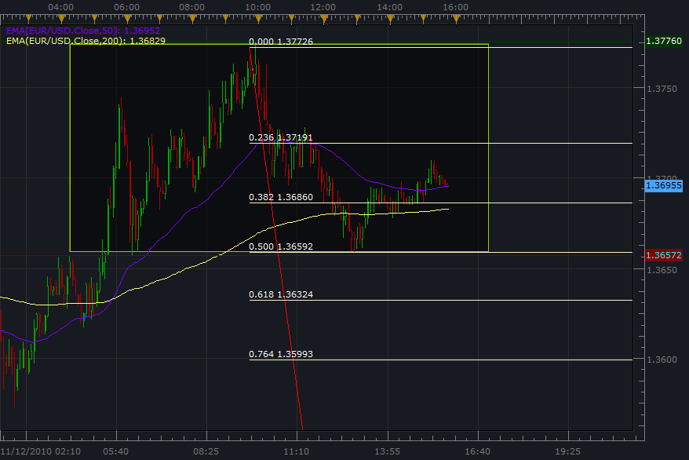

And now for the 1 min. charts which is where we do our intraday trading from. ☺

(next page)

EURUSD 1 min.

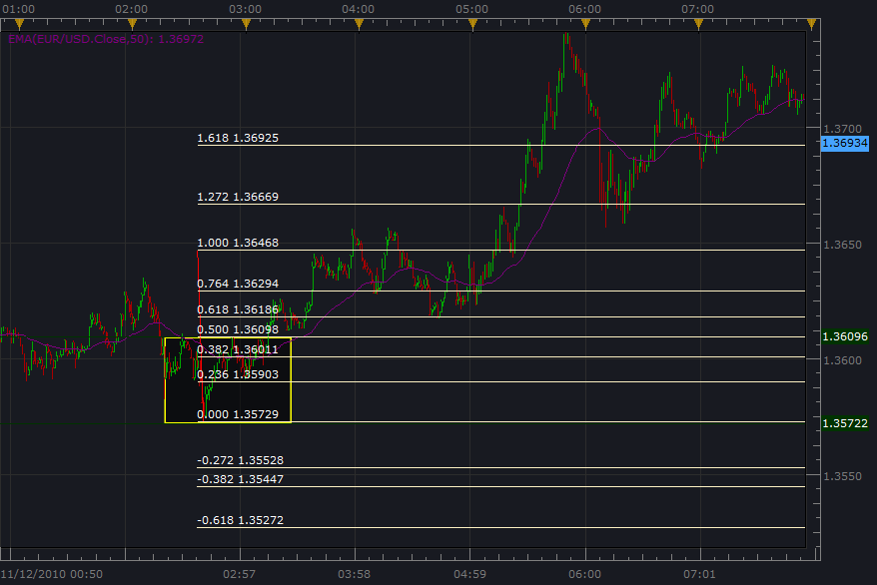

O.k. so when viewing 1 min, we have to keep in mind the larger trend, where we are in the market cycle of impulsive/corrective phase 60 min/15 min, and because 1 min. is where all the incremental movement happens, we have all kinds of opportunity both ascending and descending price movement. Generally we trade with the trend (of course), but check out how this little double bottom formation can be a little set up. We put our stop behind the nearest pullback, and when price crosses the 50% fib line, which is our Momentum breakout, our entry order is activated. This price movement even passed the golden ratio of 161.8%. (this is when we would put the 23.6% at the end of the range of the base object, but since this is going to be a downtrend impulsive phase based on the larger time frame analysis, we will be expecting 5 wave cycles with the downtrend, and our extended waves will be downward)
That’s good for now, the market open Sunday (be careful of stop runs on Sundays)
God bless. Mondays are better. Or the first session that is. Take care…. One love…

