God bless us every one…Happy Holidays ☺

So here is an example of checking the charts and waiting for the next significant price level break and clear impulsive phase in 1 minute decided upon a base object, and our forecasting….

1st the Daily EURUSD We have an obvious top which is a famous reversal pattern meaning downward sentiment is next, but price re-tested and we need the retracement price turn to break or 5 wave cycles downward in 60 min and 15 min to indicate real sentiment.

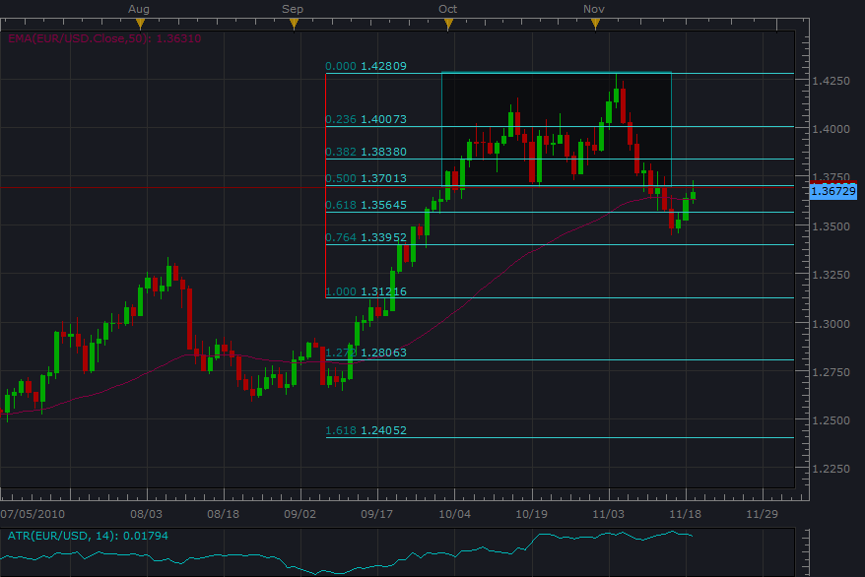

Next is the EURUSD 4 hour which shows a closer view (smaller degree) of our retest area, which needs to prove the corrective phase is over with strong red candles. For now we are in the corrective “counter trend phase” so no trading opportunity. This knowledge is important to understanding “progress” of price movement vs. price correcting from being moved based on the Interbank ebbs and flows of world investors. This is why price is the most objective indicator, because it shows the behavior of the Forex market (exchange rates of the world).

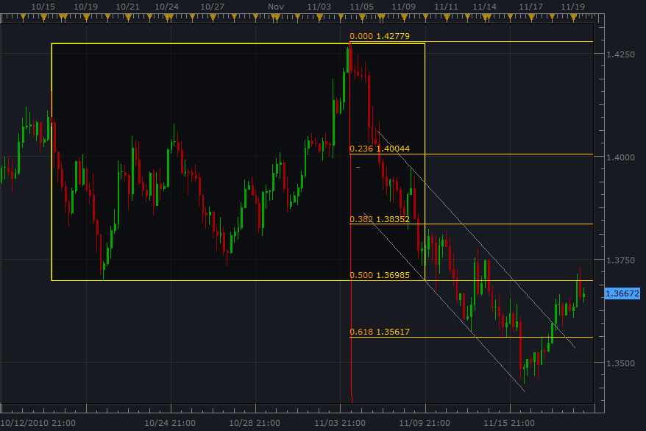

So our 4 hour “power” is an important time frame for prevailing trend momentum, and we now go to the 60 min to check wave counts and evaluate if “progress” is going back into gear at all. “Progress” will show impulsive behavior.

First of all when we squish the candles together, we get a view of a similar framing like the 4 hour “power” which connects time frames. This is important because we want the “power of 4 hour” and the wave count impulsions of the smaller time frames for setups.

So in 60 min, we can tell that our retest to the range price break area is still in countertrend/corrective mode, and we should be patient and now check 15 min for behavior also. We know of course though that being HIGH PROBABILITY THINKING PEOPLE, there is nothing here for us this morning. “Conquering our emotions”
By the way, notice how the 50 EMA is crossed in the new prevailing trend direction, the impulsion has to already be under way and crossed for this indicator to share sentiment.
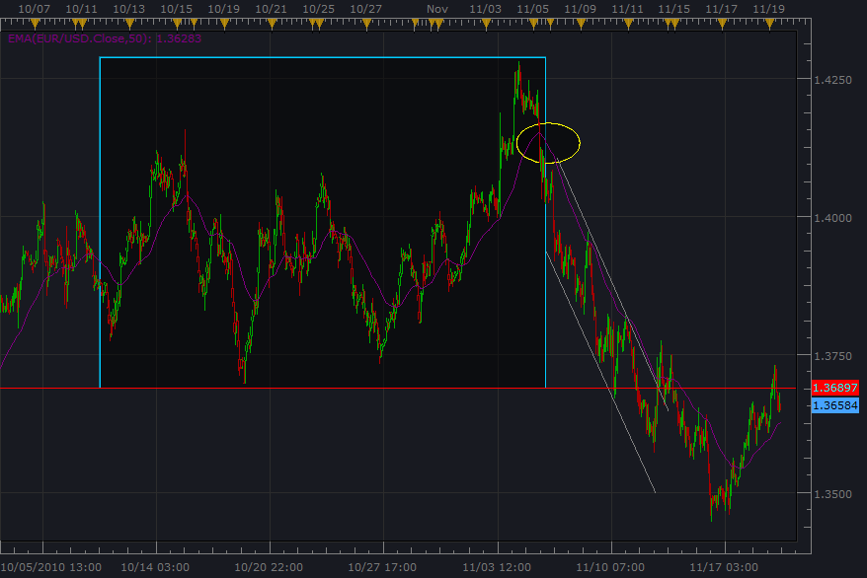

By the way if you ever spot a trade in 1 min after all the analysis (or impulsions that is), wait for price to turn before entering the trade because there may not be any chicken on the bone for the impulsion and you may get caught in short correction, so just wait for price to turn and be patient to see if there is a continuation pattern forming.

Here is 15 EURUSD, you notice the little red arrow because I was human and found a 1 min candle base object impulsion phase and entered the trade, so this was wrong to do because the 5th wave of the cycle may not go since the larger time frame is still in the corrective phase and we may have low momentum of price movement for some reason.
Anyway, I need to “practice what we preach” right? ☺
A base object top is in the “range box”

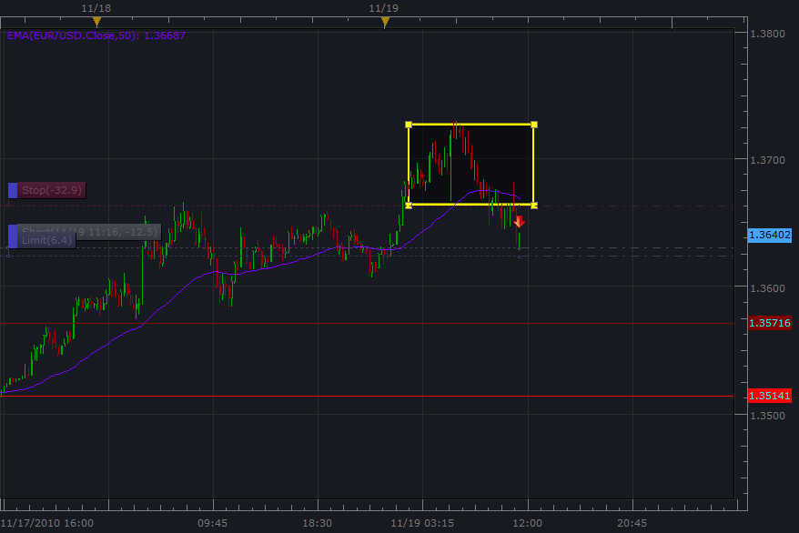

O.k. so here is 1 min, and to reveal my mistake, you can even notice my attempt to frame the flag/pennant continuation pattern. We have to remember that (this is an important lesson we are learning)…that the price turn is actually telling us where our Momentum Breakout will be, and what price level showed resistance to the previous momentum. The future break of this zone is called “trading follow through” ☺ My thought was that the huge “base object” top formation was sufficient to enter the trade, but I rushed and then panicked by putting my stop limit waaay behind the most recent pullback, this is why we have to let price unfold and our entry order goes at the end of the price turn, otherwise our nearest price turn is too far back and not good risk management. ☺

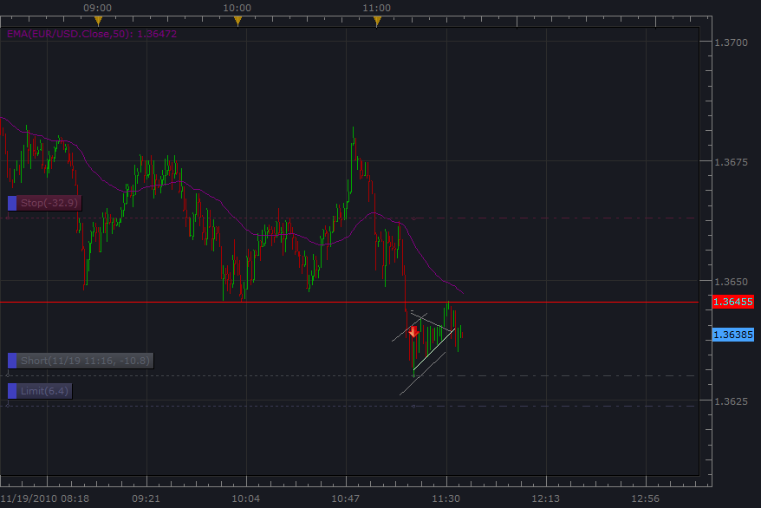

So lets track this unfolding, and I am hoping to catch 6 pips at the limit order when price goes back after the 4th wave. This is called WHOOOOPS! But it’s good to learn from….
This is why we need 300-600 trades while studying and tracking because this is how we learn…through observation…it’s also called Empirical knowledge.

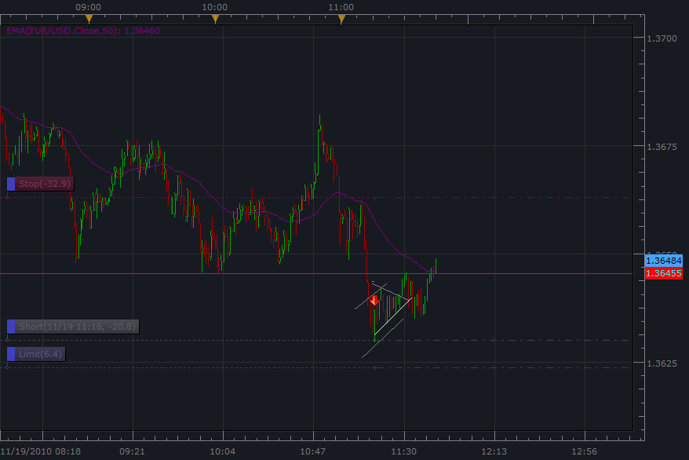

So as it shows, price decided to retest the top pattern, and because the trade was entered before price started to turn…..bad decision making on my part….this is why we work with micro lots…10 cents a pip….to learn these lessons of “retests” and Momentum breakout thinking.

So here’s a question….now that price is up near the “top” zone/base object…
If one of us hadn’t entered the trade yet…. And noticed the retest with the terrific little top/base object there.
Do we enter here and try to get downward price movement that we think will follow?
Well price just proved a new price level before this retest/pullback, so Momentum breakout thinking says….no go…..We have to wait for the price turn that happened to break for an entry order.

Here is 1 min again….and if there happened to be a significant news announcement/interest rate “carry trade” price can really do anything….so this was a bad entry….and as it was mentioned…”rushed into” However, as part of our practice…this is something to learn from because we now know that the price turn has to be clearly set before we do anything and can count impulsion and evaluate the base object in the recent area. Again this trade was entered as the impulsion was in process, and the turn happened right as the entry order happen, and then seemed to be a continuation pattern then ended up retesting the base object break area…….we live n learn….hopefully this one goes back, which it probably will (all things equal)….

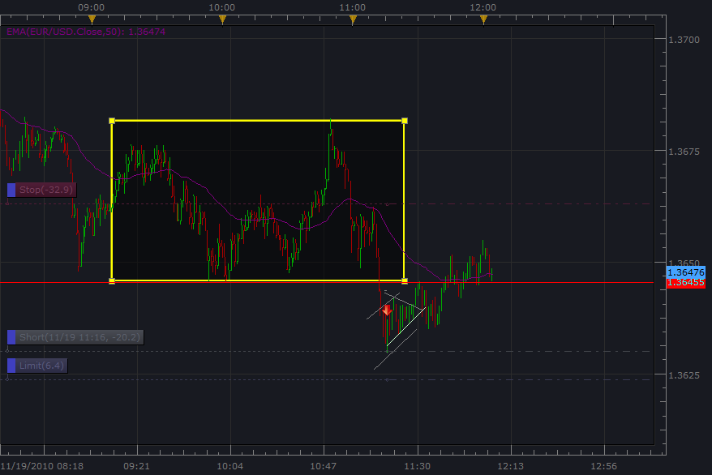

Uh oh….here is the 15 min “location” which shows that we do not have a sufficient top in place (base object) to have entered the trade in the first place……earlier on, we had said “well nothing for us here”, so what happened……well….I’m human and did not follow the rules…..well that’s what the practicing part is and we cannot beat ourselves up about it…..of course this lesson should be an example to use in the future of what not to do, and we process the need for 1) overall trend 60 min/15 min “location” base object/top in place that broke the trend line/channel of the correction 2) price turn to establish our entry order point….. Good lesson ☺

Uh oh…it seems that the stop loss just got stopped out….Well time to think about the lesson about 60 min/15 min structure criteria and 1 min. price turn criteria. Any when we say no opportunity, to provide ourselves the reason why ☺

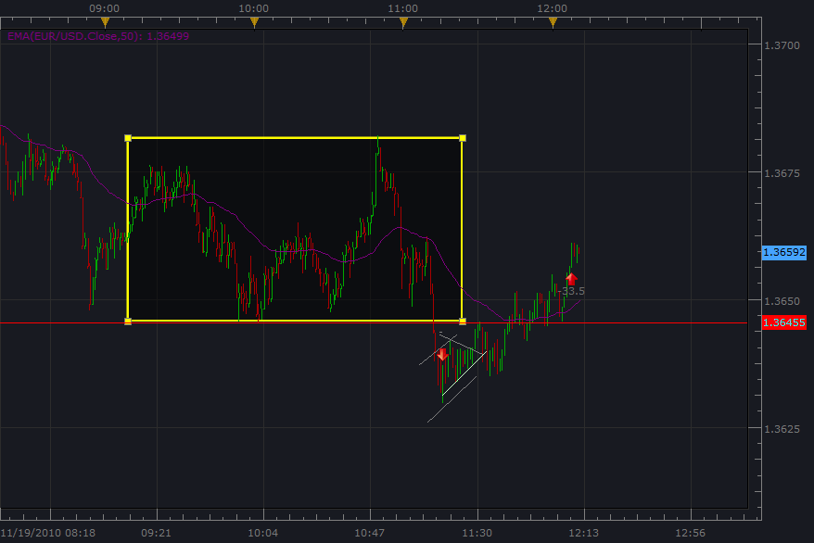

O.k. so what was the lesson again…..we need 60 min/15 min structure and prevailing trend corrective phase to end, and always the 1 min price turn to happen before establishing parameters of a trade. No problem this is practice……and later on, this lesson should be internalized we hope…..God bless….we are all human…. ☺

By the way, here the channel hadn’t even broken in 60 min, so this is important

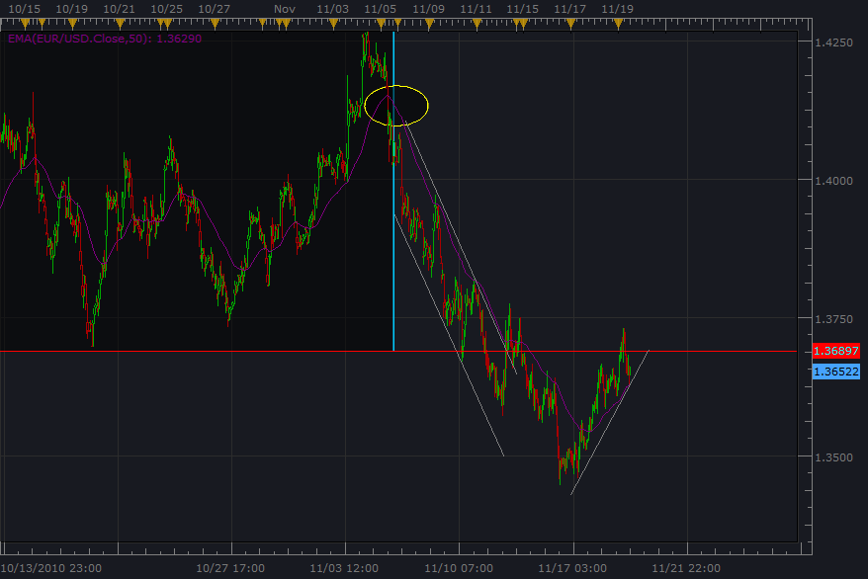

Here is 15 which may seem like there is something, but the 60 min is our “significant” view. So we go by this. Remember that the trend line indicates the “ordered growth” that occurs in both TREND and COUNTERTREND price movement. Well at least we are developing a depth of understanding about this idea. ☺
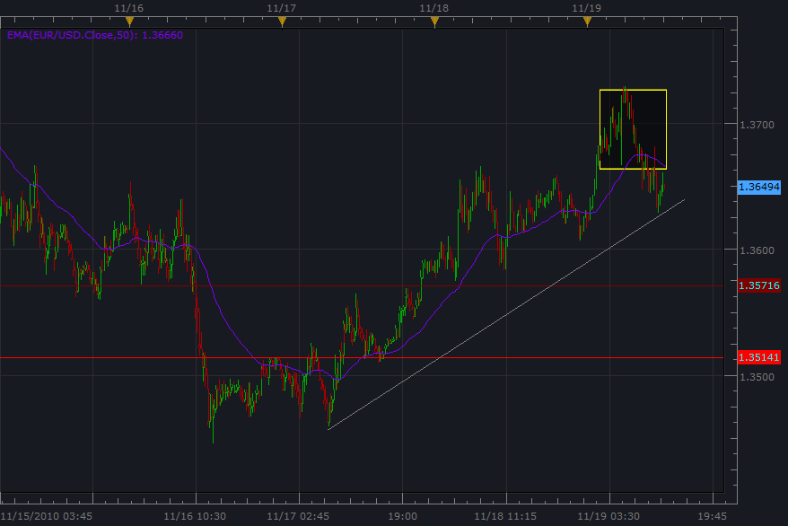

So it’s very important when we view smaller time frames to keep in perspective what is REALLY going on in 60 min and 15 min…If we do not have a true top/base object with a price level break or channel/trend line break….we are not presented with an opportunity for a trade setup…our setups are in smaller time frames, and we have to only go to this place if 60 min and 15 min tell us to…we could draw all kinds of stuff in 1 min, but it doesn’t mean anything unless the more significant time frames say that the correction has completed…...that’s called an AHA moment ☺
Take care……God bless…..

So this mistake was the “oh…..wait…there it goes….emotional rushing into it…and then a price turn happens which is part of a larger time frame channeling corrective phase…”
As they say it’s Punishing, if one does not get out of the trade.

Here are some winning trades just to let you know it’ possible, but I put it all back to the market….what a lesson though…..hopefully I remember this one. ☺

Here is 20+ pips
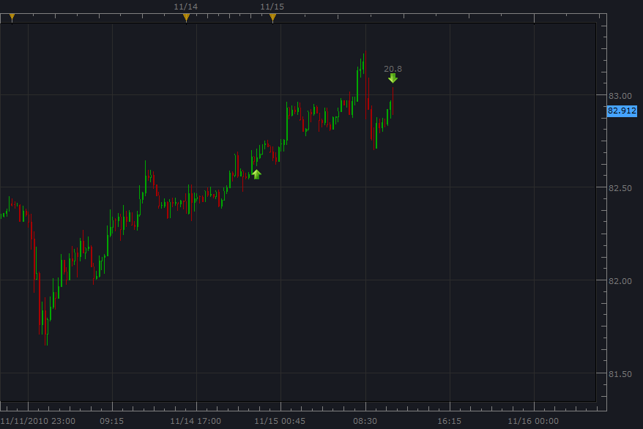

Here is 9.4 + pips

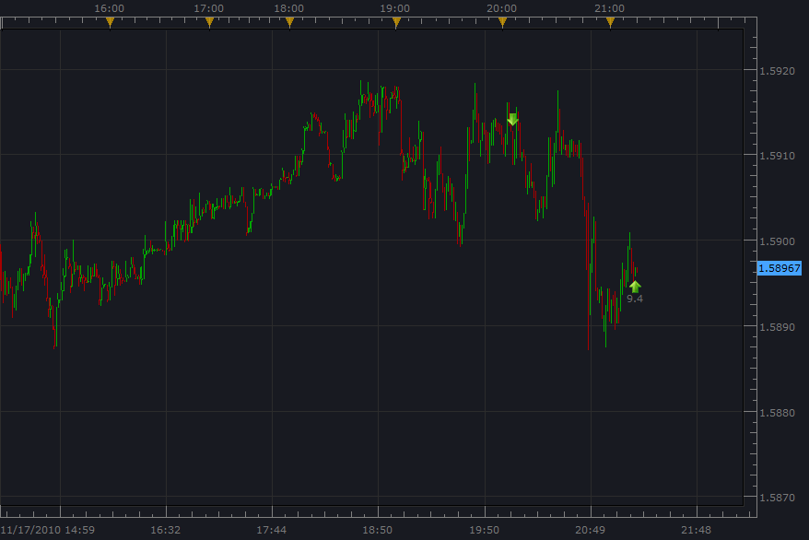
Here is 5+ pips

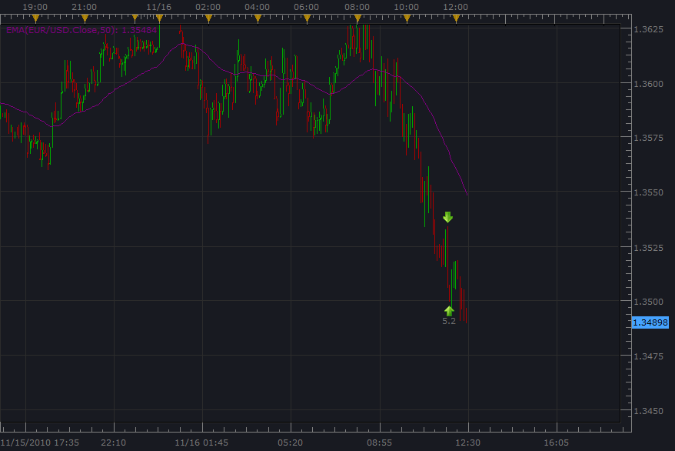
It’s a journey so lets keep learning and take it easy on ourselves…..When a trade is entered always double check if the corrective channel has been broken and a significant price level was crossed or our intra day turned swing trade could be a real mess….All in good time we are learning…..and having fun ☺
God bless….Happy Holiday…Everyday is a holiday and every meal is a banquet. ☺

