God bless and Happy Holidays buddy…

So here is a winning EURUSD swing trade (128+ pips from “first wave n a pullback and entry order as price crossed the Momentum breakout point) because chasing the 1 min waves got in the way of my art projects and prayers. (God before anything of course-the prayer is on the first page of the site) ☺ Thank you GOD for helping us…. ☺

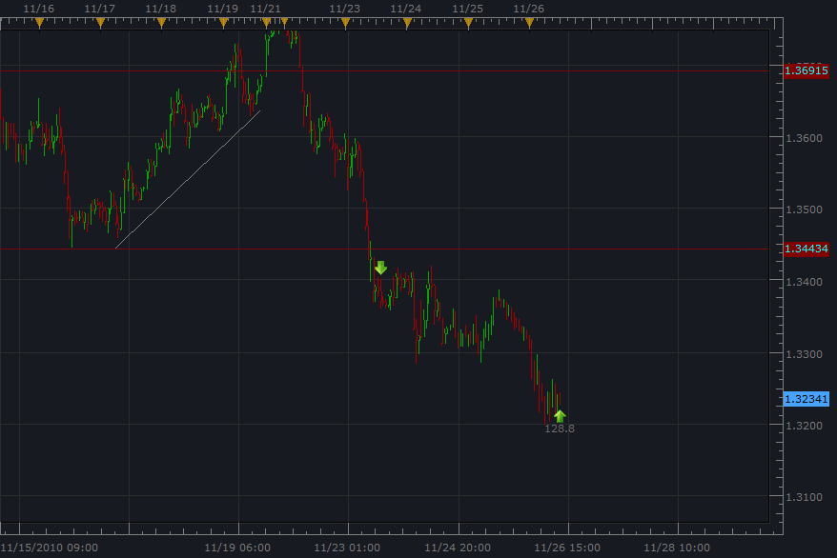

So here is a low risk approach to swing trading, especially when we have a turn in USD strength, as well as JPY aware that this will increase export buying due to USD purchasing power (more than 20% of exports in JPY).

So just for fun, I have an entry order with Micro account (10 cents a pip) and plan to add or take away lots as the wave cycles unfold. Using the 10 cents increment to stay in the trade, and putting the stop at the low beyond 80.00 which is “psychological support” that goes all the way back to 1997. Price bounced pretty well off this area, so we are going to use this information, as well as EURUSD decline in significant time frames, as well as the DXY strength (bottom).

So below, we are witnessing the bounce at 80.00 with our Fib. Range forecast price already broke 100%, and it may go to 161.8% ☺ A friend said one time that he noticed remarkable price reflection of the wave principle. God bless. ☺

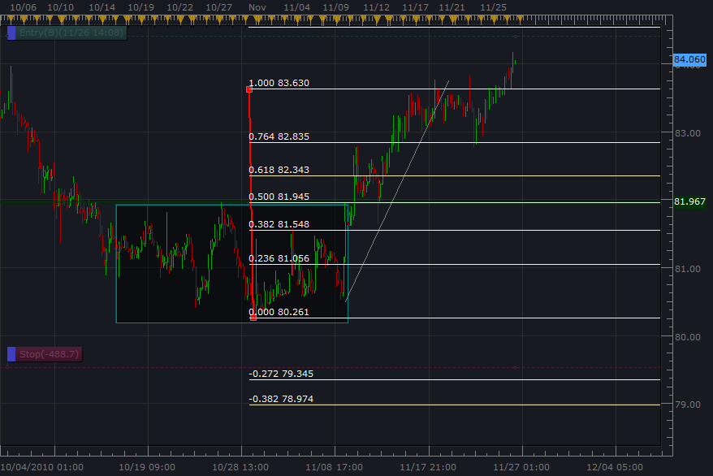

So the stop limit was placed below the 80.00 line (an expert said to place the stop away from the line because price may touch the psychological support amazingly and bounce off it. The idea is to be in the trade with a good enough stop protection the currency pair corrects, and we can add lots or subtract lots based on the impulsive/corrective phases. Price is said to have reached the bottom so we will just stay in this one for the long term. ☺

O.k so with the 10 cents a pip stop loss already placed and the entry order above the 100% to get in on this one, because folks, this is apparently going to be a time of USD strength and our famous Kimono traders (all respect due, Yoro Shiku), will probably be doing their “perma bear” thing as scholars have noted. This means that going short the Yen will strengthen the economy due to all the buying power of other world currencies. ☺ God bless. ☺

Here is USDJPY in 1997 when it bounced of the 80.00 psychological support.
So we are using this as a significant “weekly” time frame to base our long term position.

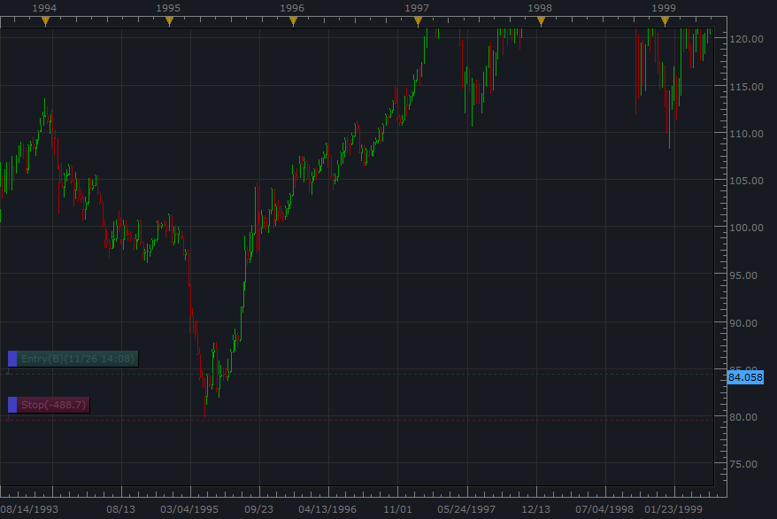

O.k. so that’s the idea of this one, and at worst the risk is about 50$ if price goes past 80.00 As price rallies, we can add and remove lots. We have high probability opportunity at impulsive 60 min phases and will try to keep track.

We will follow this one…Lots of love and prayers from all of us. ☺

