Peace to all of us ☺

So what are some 3 important points to remember in Forex strategy?

- Prevailing trend, currency pair correlation confirmations, DXY (or your pair’s index correlation that shares sentiment), economic calendar. Find an impulsion phase, because the corrective phase “slips out of gear” as Elliot said. Our “ordered growth” strategy is based on trading the impulsive phase. “It’s either impulsive or corrective” ☺

Here is an example of how a not so good economic indicator report regarding un-employment shows itself as a wave 2 corrective sentiment in the recent USDJPY.
Interesting how the break of the channel (tells us that “universal law” of “ordered growth” is ending) coincides with the un-optimistic “non-farm payroll report”.
On Dec 3rd, the USD un-employment rate increased to 9.8% and NFP’s were reported 39K instead of the previous 172K.

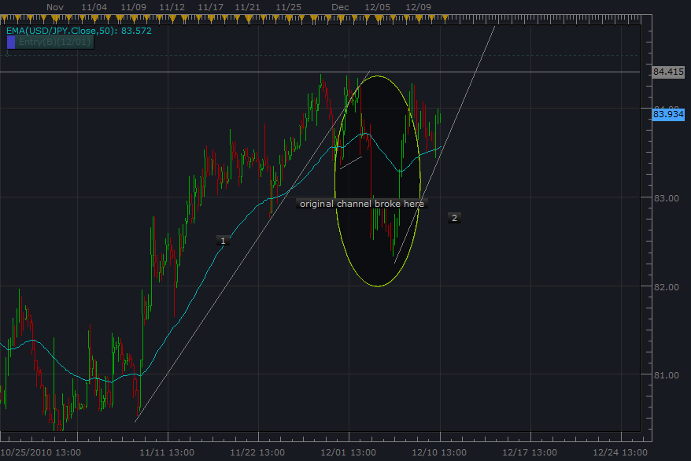

- Significant time frame (daily, 4hour, and 60 min) wave count. Note positioning, structure. For entry order we use the Momentum breakout strategy with minimum risk possible behind pullback. For 5th wave we put entry order a bit more beyond end of wave 3 in case of truncation. Have we already had an extended wave?

- Draw trend line/channel to show us when “ordered growth”/”universal law” is transitioning to corrective phase. (trend line break). (We can add or reduce lots based on 15 min. structure. If we get good base objects, we can profit from “structure within structure” impulsive phases. Other wise it’s a swing trade and trend line breaks/reversal patterns in 4 hour/60 min. tell us to close the position.)

God bless. Happy Holidays.

