God bless…..we must listen to our awareness that kindness is the most important thing.

Be careful listening to mean people’s advice, it can be harmful (obviously right?)
And after the harm, they will not be there to help…so we must protect our minds and hearts by trying to lighten up and know that we are in control and special too….
This is because the motivation behind their thinking is not love…

Faith, Hope, and Love….Take care….

SO when we are deciding which “significant” time frame to place an entry order at the Momentum breakout point (with the most reasonable stop possible)

Structure beneath is our criteria…

So here we have the EURUSD using the 50% Fib. off the range….Will this go to 1.1500 the “golden ratio”?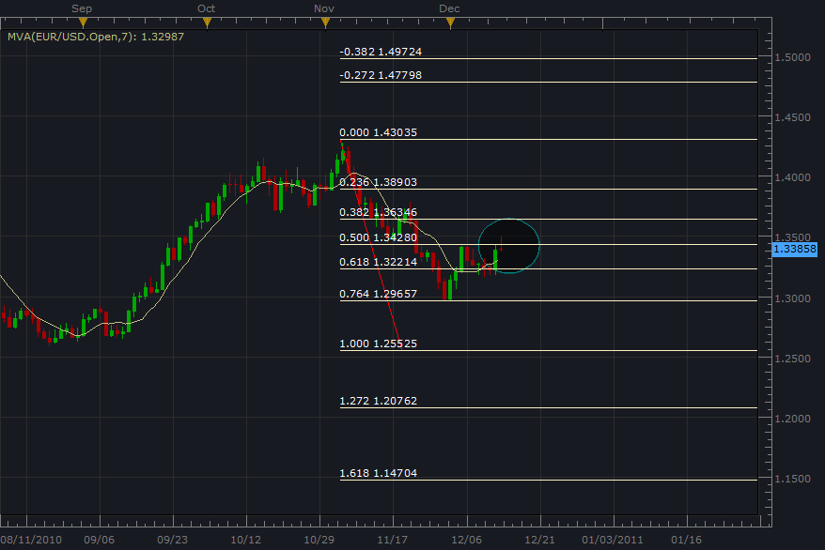

Here is a better view of the structure EURUSD
The blue “ellipse” is where the entry order should be placed for Highest probability entry. WE trade follow through, and when this price level is reached….we have sentiment.
Note that the when we use the 50% Fib. forecast, 76.4% is where our “golden ratio-161.8%” would have been if we used 100% at the end of wave 1.

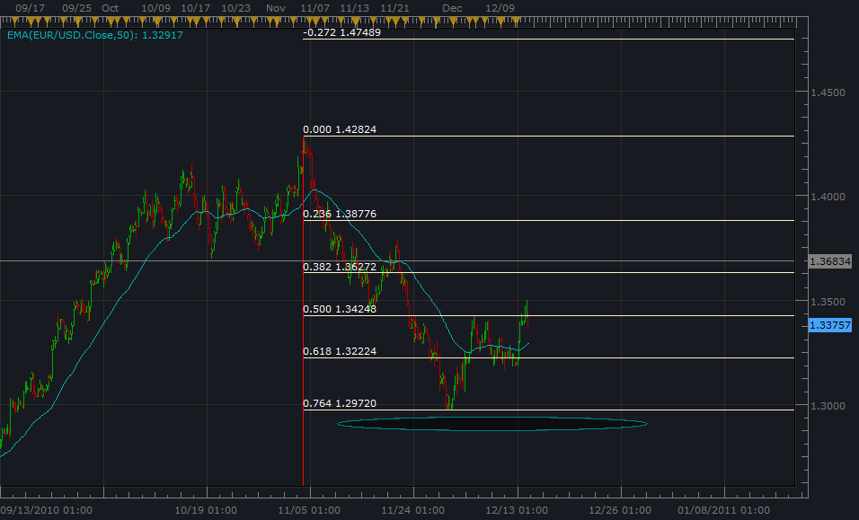

Lots of love and prayers…..

